
Sukkur Institute of Business Administration University
Department of Computer Science
BS – I (CS/SE) Fall 2025
Programming Fundamentals
Lab # 02: To become familiar with use of variables and datatypes

Lab Report Rubrics  (Add the points in each column, then add across the bottom row to find the total score) |  |  |  |  | Total Marks
S.No | Criterion | 0.5 | 0.25 | 0.125
1 | Accuracy | - Desired output | - Minor mistakes | - Critical mistakes
2 | Timing | - Submitted within the given time | - 1 day late | - More than 1 day late
Submission Profile
Name: Submission date (dd/mm/yy):
Enrollment ID: Receiving authority name and signature:
Comments: __________________________________________________________________________
Instructor Signature

Note: Submit this lab hand-out in the next lab with attached solved activities and exercises

Objectives
After performing this lab, students will be able to
- Use variables
- Get input from users
- Understand and use data types

Variables
All computers have memory, called RAM (short for random access memory), that is available for your programs to use. You can think of RAM as a series of numbered mailboxes that can each be used to hold a piece of data while the program is running. A single piece of data, stored in memory somewhere, is called a value.
In C++, direct memory access is not allowed. Instead, we access memory indirectly through variables. Variables represent storage locations in the computer’s memory that are given some name. You can consider them like small blackboards, where we can write some value and change/update it later if we want.

Literals
A literal (also known as a literal constant) is a fixed value that has been inserted directly into the source code. For example, in the following two code samples, the first one contains a fixed string (collection of characters) Hello World, and the second line shows an integer literal 45 is saved in a variable named n.
cout << “Hello World”;
int n = 45;
When we give some value to a variable, we just use that variable (name) to access that value at any place in the program. For example:
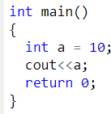
Output: 10
Here we just print/display the variable “a” but we get its value (10) as output.

Identifiers
Variables (or function) names are called identifiers. An identifier is a programmer-defined name that represents some element of a program. Variable names are examples of identifiers. You may choose your own variable names in C++, as long as you do not use any of the C++ keywords. The keywords make up the “core” of the language and have specific purpose/meaning. So, you cannot use them as a name of your variables. A list of such keywords is shown in the following table
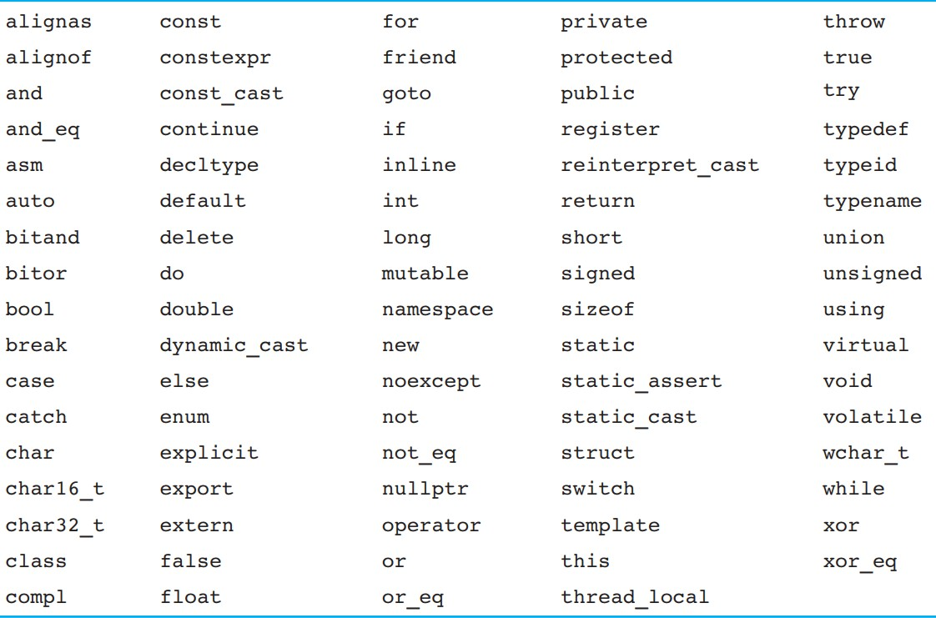

Identifier naming rules
C++ gives you a lot of flexibility to name identifiers as you wish. However, there are a few rules that must be followed when naming identifiers:
- The identifier cannot be a keyword. Keywords are reserved.
- The identifier can only be composed of letters (lower or upper case), numbers, and the underscore character. That means the name cannot contain symbols (except the underscore) or whitespace (spaces or tabs).
- The identifier must begin with a letter (lower or upper case) or an underscore. It cannot start with a number.
- C++ is case-sensitive and thus distinguishes between lower-case and upper-case letters. So,
nvalue is different from nValue and NVALUE.

Some examples of valid and invalid variable names are shown in the table below

Variable Name | Valid/Invalid
age | Valid
my_score | Valid
num1 | Valid
2num | Invalid (starts with a number)
student id | Invalid (contains a space between two words)
_height | Valid
my_math_marks | Valid
productName | Valid

Defining variables
Before use, variables must be defined. The general syntax of defining a variable is shown below:

Data_type variable_name;

In other words, we just need to tell the compiler
- type of data is going to be stored in this variable
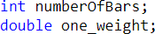
- name of the variable for example,

The keyword int is an abbreviation for integer, which are used to store whole numbers (numbers without decimals/points). They can store values like 3, 102, 3211, -456, etc. The variable defined in the above-given figure, numberOfBars, is of type integer.

The datatypes double and float represent numbers with a fractional component and can store values like 1.34, 4.0, -345.6, etc. In the code sample shown above, the variable one_weight is of type double.

Defining more than one variable in a single statement
You can declare more than one variable on the same line separating them by commas. The general syntax is shown below:

Data_type variable1_name, variable2_name, …;
For example, the following line defines three variables of type int in a single statement;
int math_marks, eng_marks, phy_marks;

Assignment Statements
An assignment statement is used to store a value in a variable (or to change the value of a variable). For example,
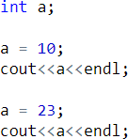

Output:
Assignment statements end with a semi-colon. The single variable to be changed is always on the left of the assignment operator ‘=’. On the right of the assignment operator can be
- Constants, like age = 21;
- Variables, like myCost = yourCost;
- Expressions, like circumference = diameter * 3.14159;
The value to be assigned cannot be on the left-side. For example, the following assignment is invalid

Initializing Variables
Defining a variable does not give it a value. Giving a variable its first value is called initializing the variable. Variables are initialized in (or using) assignment statements
int age; // define the variable age = 23; // initialize the variable
Definition and initialization can be combined in a single statement using the following methods:
Method 1: int age = 23;
Method 2: int age (23);
Method 3: int age {23};

Uninitialized variables
Unlike some programming languages, C/C++ does not initialize most variables to a given value (such as zero) automatically. Thus, when a variable is assigned a memory location by the compiler, the default value of that variable is whatever (garbage) value happens to already be in that memory location! A variable that has not been given a known value (usually through initialization or assignment) is called an uninitialized variable. Using the values of uninitialized variables can lead to unexpected results.
Consider the following short program:

// define an integer variable named x
int x; // this variable is uninitialized because we haven't given it a value

// print the value of x to the screen
std::cout << x; // who knows what we'll get, because x is uninitialized
In this case, the computer will assign some unused memory to x. It will then send the value
residing in that memory location to std::cout, which will print the value (interpreted as an
integer). But what value will it print? The answer is “who knows!”, and the answer may (or may not) change every time you run the program.

Getting input from the user
cin is an input stream bringing data from the keyboard. And sends/stores in the variable given/written on its right side.
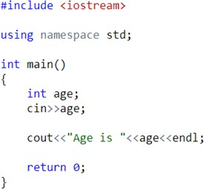

Then, when the code is run, the program will wait for the user to give some input and show a cursor like shown below:
And when the user presses the Enter/Return key after giving some number, then that value is saved in the variable age and then displayed.
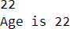

However, it is a good practice to show a prompt message to the user asking him/her to input some value before the cin statement.

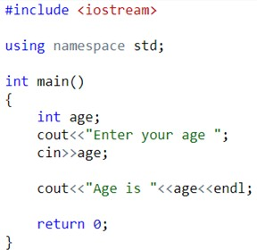

Then a prompt, like the one shown below, will be sown to the user
And the rest of the program will work like discussed on the previous slide
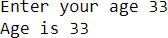
You can also get input for multiple variables using a single cin command, as shown below:

Then, at run-time, input three values separated by spaces.

Data Types
Because all data on a computer is just a sequence of bits, we use a data type (often called a “type” for short) to tell the compiler how to interpret the contents of memory in some meaningful way.
When you give an object a value, the compiler and CPU take care of encoding your value into the appropriate sequence of bits for that data type, which are then stored in memory. For example, if you assign an integer object the value 65, that value is converted to the sequence of bits 0100 0001 and stored in the memory assigned to the object.
Conversely, when the object is evaluated to produce a value, that sequence of bits is reconstituted back into the original value. Meaning that 0100 0001 is converted back into the value 65.
Fortunately, the compiler and CPU do all the hard work here, so you generally don’t need to worry about how values get converted into bit sequences and back.
All you need to do is pick a data type for your object that best matches your desired use

C++ Fundamental Data Types
The table below shows the fundamental data types, their meaning, and their sizes (in bytes):

Data Type | Meaning | Size (in Bytes)
int | Integer | 2 or 4
float | Floating-point | 4
double | Double Floating-point | 8
char | Character | 1
wchar_t | Wide Character | 2
bool | Boolean | 1
void | Empty | 0

Now, let us discuss these fundamental data types in more detail.

The int data type
  - The int keyword is used to indicate integers (whole numbers without having any fractional part/number after decimal).
  - Its size may vary between 2 to 4 bytes on different compilers but is usually 4 bytes. Meaning, it can store values from -2147483648 to 2147483647.
Example:
int salary = 85000;

The float and double data types
  - float and double data types are used to store floating-point numbers (decimals and exponentials).
  - The size of float is 4 bytes and the size of double is 8 bytes. Hence, double has two times the precision of float.
Example
float area = 64.74f;
double volume = 134.64534;
Note that by default, floating point literals (values with decimal points) are considered of type
double. An f suffix is used to denote a literal of type float. These two data types are also used for exponentials.
For example:
double distance = 45E12 // 45E12 is equal to 45*10^12
This way of writing numbers is called scientific notation. The letter E denotes the exponent part and can be either lower case “e” or upper case “E”.

The char data type
  - Keyword char is used for characters.
  - Character data is where we want to store only one character like any one of the alphabets or special characters.
  - The size of char data type is 1 byte.
  - Characters in C++ are enclosed inside single quotes ' '. Example:
char test = 'h';

The bool data type
  - The bool data type has one of two possible values: true or false.
  - Booleans are mostly used in conditional statements and loops (which we will learn in later chapters).
Example
bool cond = false;

The void data type
  - The void keyword indicates an absence of data. It means "nothing" or "no value".
  - We will use void when we will learn about functions and pointers.
Note: We cannot declare/create variables of the void type.

C++ Type Modifiers
We can further modify some of the fundamental data types by using type modifiers. There are 4 type modifiers in C++. They are:
  - signed
  - unsigned
  - short
  - long

C++ Modified Data Types List
Data Type | Size (in Bytes) | Meaning
signed int | 4 | used for integers (equivalent to int)
unsigned int | 4 | can only store positive integers
Short | 2 | used for small integers (range -32768 to  32767)
Long | at least 4 | used for large integers (equivalent to long int)
unsigned long | 4 | used for large positive integers or 0 (equivalent  to unsigned long int)
long long | 8 | used for very large integers (equivalent to long long int).
unsigned long long | 8 | used for very large positive integers or 0  (equivalent to unsigned long long int)
long double | 8 | used for large floating-point numbers
signed char | 1 | used for characters (guaranteed range -127 to 127)
unsigned char | 1 | used for characters (range 0 to 255)
Let's see a few examples.
long b = 4523232;
long int c = 2345342;
long double d = 233434.56343;
short d = 3434233; // Error! out of range
unsigned int a = -5; // Error! can only store positive numbers or 0

Derived Data Types
Data types that are derived from fundamental data types are derived types. For example: arrays, pointers, function types, structures, etc.
We will learn about these derived data types in later tutorials.
Activity:
Write a program in which you declare and initialize all the countable and measurable datatypes provided by dev-C++ compiler. Moreover, you are required to print the minimum and maximum range of values that can be stored in those variables along with the space occupied by those variables in the memory.

Solution:

#include <iostream>

#include <climits>

#include <cfloat>

#include <float.h>

using namespace std ;

int main (){

short s1 = 10 ;

signed short s2 = 20 ;

unsigned short s3 = 30 ; int i1 = 10 ;

signed int i2 = 20 ;

unsigned int i3 = 30 ;

long l1 = 10 ;

signed long l2 = 20 ;

unsigned long l3 = 30 ;

long long ll1 = 10 ;

signed long long ll2 = 20 ;

unsigned long long ll3 = 30 ;

float f = 9.123456789 ;

double d = 9.123456789000000 ;

long double ld = 9.1234567890000000000 ;

cout << "\n\n Check the upper and lower limits of countable datatypes :\n";

cout << " \n";

cout << " The maximum limit of int data type : " << INT_MAX << endl;

cout << " The minimum limit of int data type : " << INT_MIN << endl;

cout << " The maximum limit of unsigned int data type : " << UINT_MAX << endl;

cout << " The maximum limit of long long data type : " << LLONG_MAX << endl;

cout << " The minimum limit of long long data type : " << LLONG_MIN << endl;

cout << " The maximum limit of unsigned long long data type : " << ULLONG_MAX << endl;

cout << " The minimum limit of short data type : " << SHRT_MIN << endl;

cout << " The maximum limit of short data type : " << SHRT_MAX << endl;

cout << " The maximum limit of unsigned short data type : " << USHRT_MAX << endl;

cout << " The minimum limit of float data type : " << FLT_MIN << endl;

cout << " The maximum limit of float data type : " << FLT_MAX << endl;

cout << " The minimum limit of double data type : " << DBL_MIN << endl;

cout << " The maximum limit of double data type : " << DBL_MAX << endl;

cout << " The minimum limit of long double data type : " << LDBL_MIN << endl;

cout << " The maximum limit of long double data type : " << LDBL_MAX << endl;

cout << endl;

cout << "\n\n Check the space of memory occupied by countable datatypes :\n";

cout <<"The s1 size in memory = " <<sizeof (s1) <<endl;

cout <<"The s2 size in memory = " <<sizeof (s2) <<endl;

cout <<"The s3 size in memory = " <<sizeof (s3) <<endl;

cout <<"The i1 size in memory = " <<sizeof (i1) <<endl;

cout <<"The i2 size in memory = " <<sizeof (i2) <<endl;

cout <<"The i3 size in memory = " <<sizeof (i3) <<endl;

cout <<"The l1 size in memory = " <<sizeof (l1) <<endl;

cout <<"The l2 size in memory = " <<sizeof (l2) <<endl;

cout <<"The l3 size in memory = " <<sizeof (l3) <<endl;

cout <<"The ll1 size in memory = " <<sizeof (ll1) <<endl;

cout <<"The ll2 size in memory = " <<sizeof (ll2) <<endl;

cout <<"The ll3 size in memory = " <<sizeof (ll3) <<endl;

cout <<"The f size in memory = " <<sizeof (f) <<endl;

cout <<"The d size in memory = " <<sizeof (d) <<endl;

cout <<"The ld size in memory = " <<sizeof (ld) <<endl;

return 0 ;}

Exercises:
- Write a program that takes 5 values from user. Two values of integer and two values of float and one value of char data type. Print each result on a separate line.

- Write a program that takes voltage and current from user, saves them in respective data types (I and R as float or double and V as int), and calculates Resistance as per the following formula:
$$Resistance (R)= \frac{Voltage(V)}{Current(I)}$$

- Write a program, in which you create three variables to set the marks (out of 100) for ICT, Math and English subjects for Ayaz. Afterwards, your program should calculate his obtained marks in all three subjects. The sample output is shown below.
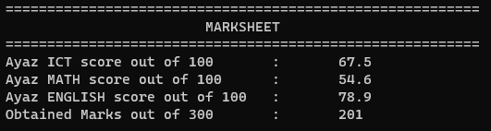

- Write a program that asks the user to type character then the program will generate its ASCII value. The sample output is shown below:
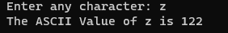

- Write a program that asks the user to type lowercase (small) alphabet character then the program will generate its uppercase (capital) alphabet character. The sample output is shown below:
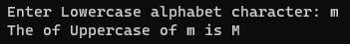

- Write a program that asks the user to type uppercase (capital) alphabet character then the program will generate its lowercase (small) alphabet character. The sample output is shown below:
